Town of Shandaken
County of Ulster
State of New York

The Town of Shandaken Town Board conducted a Regular Monthly Meeting on Monday March 4, 2019. Shandaken Town Hall. 7209 Rt. 28 Shandaken, NY

Call to Order
Pledge of Allegiance
Roll Call

Members Present Robert Stanley – Supervisor
Gael Alba - Board Member
Peter DiSclafani – Board Member
Kevin VanBlarcum – Board Member
Faye Storms – Board Member

Recording Secretary Joyce Grant - Town Clerk

On a Stanley/Storms motion the Town Board unanimously approved the minutes of the previous meeting as submitted by the Town Clerk.

Town of Shandaken Town Board
Regular Monthly Meeting Agenda
Monday, March 4, 2019
- Call to Order
- Pledge of Allegiance
- Roll Call
- Approval of previous T/B Meeting minutes
- Supervisor’s Financial Report
- Communications
- Committee Reports:
  - Ambulance
  - Building/Zoning
  - Police
  - Phoenicia Water
  - Pine Hill Water
  - Museum
  - Recreation
- Public Comments on Resolutions
- Motions:
- Resolutions:
      - Pay All Bills
      - Town Board – Approve Medical Building Lease
        - Medical Associates of the Hudson Valley
      - Town Board – Rename Old Rte. 28 (Phoenicia) to Veteran’s Way
      - Ambulance – Hire Ambulance Personnel
        - M. Williams – FT Medic @ $19.30/hr
        - T. Surak – PT EMT @ $12.10/hr
      - Highway – Award Gravel Crushing Bid
      - Town Board – Set Public Hearing to Apply for CDBG Funds
        - Monday, April 1, 2019 @ 6:45pm
      - Appoint Marriage Officiant – Alan Fliegel
- Open Public Comment
- Meeting Adjournment - IN MEMORY OF: Carol Urban
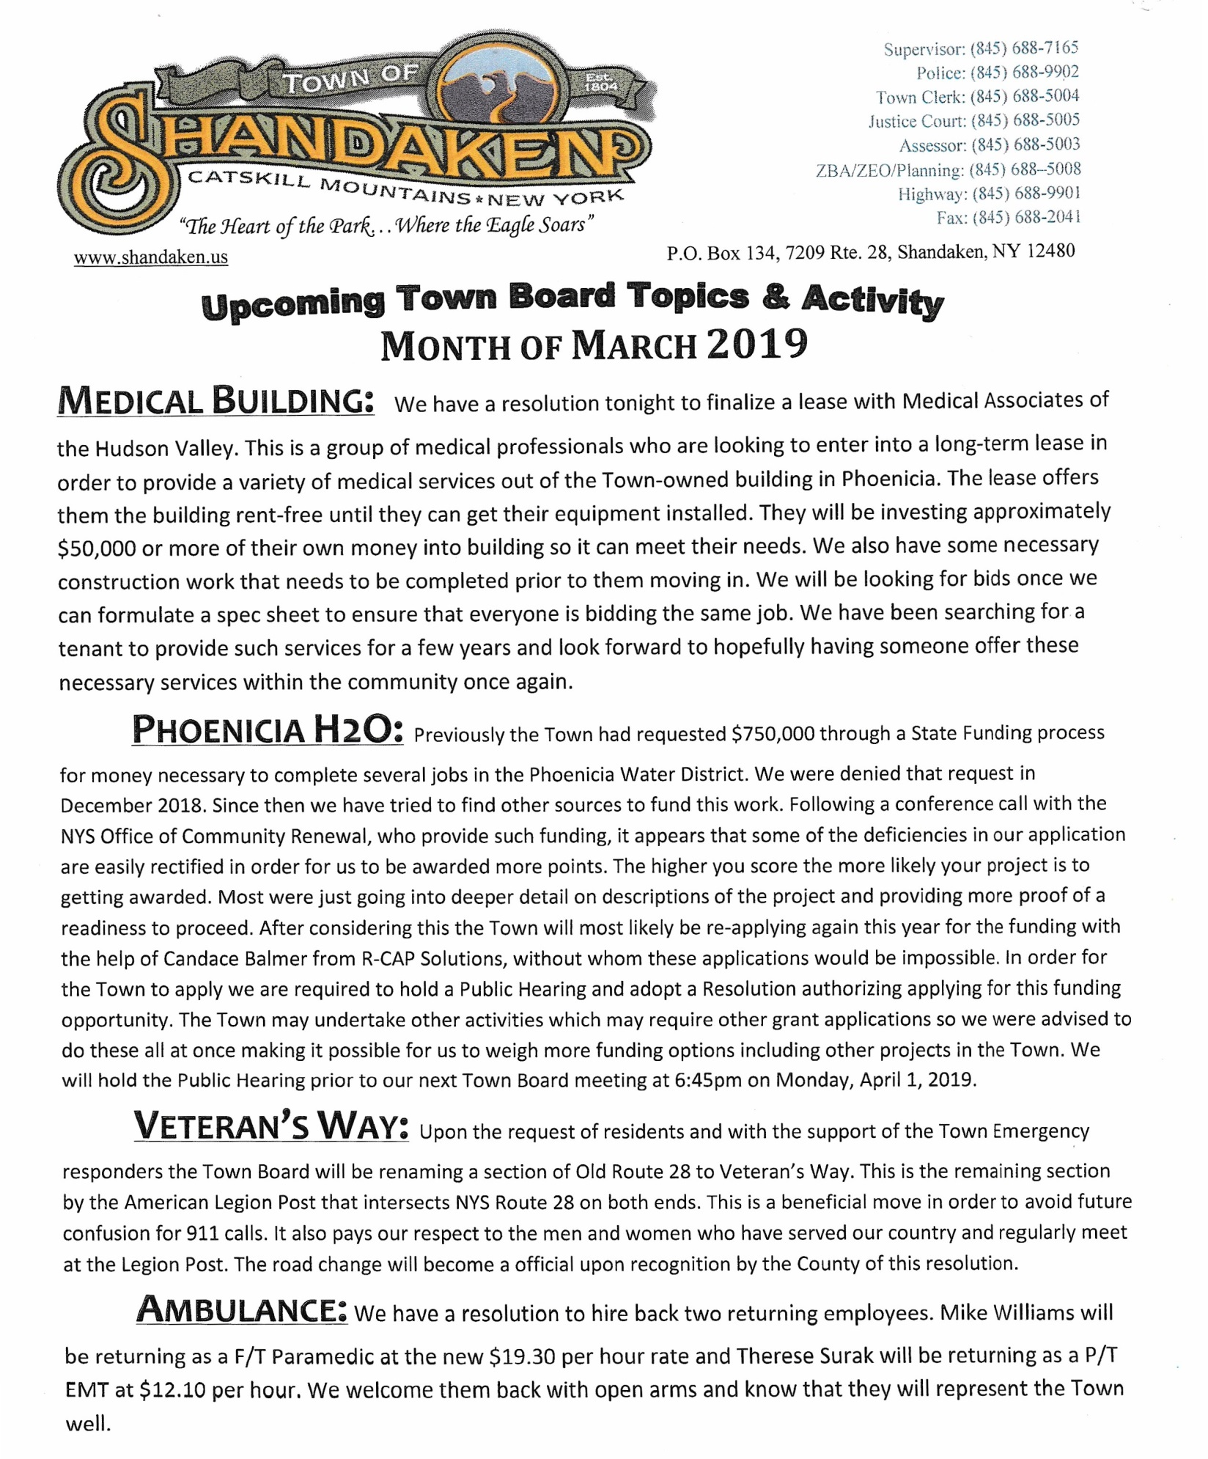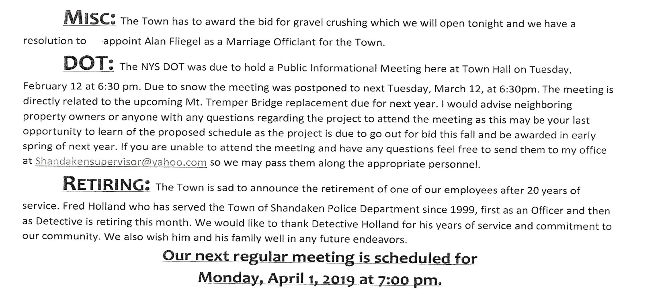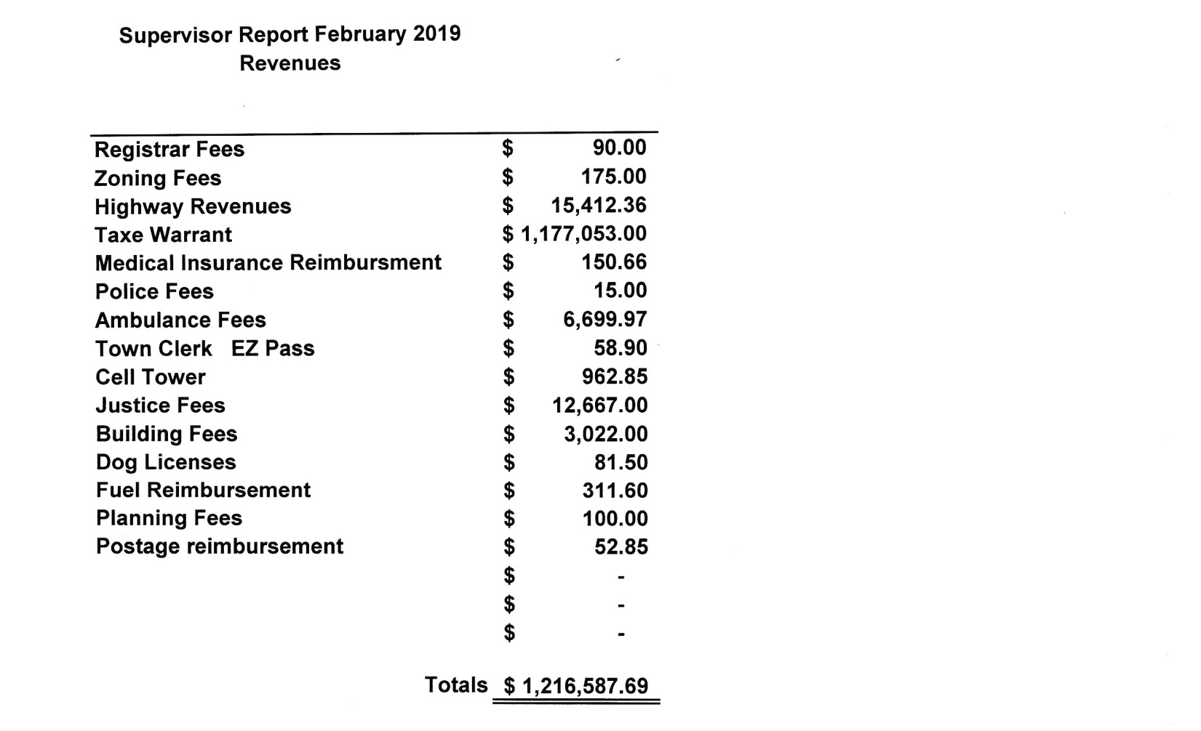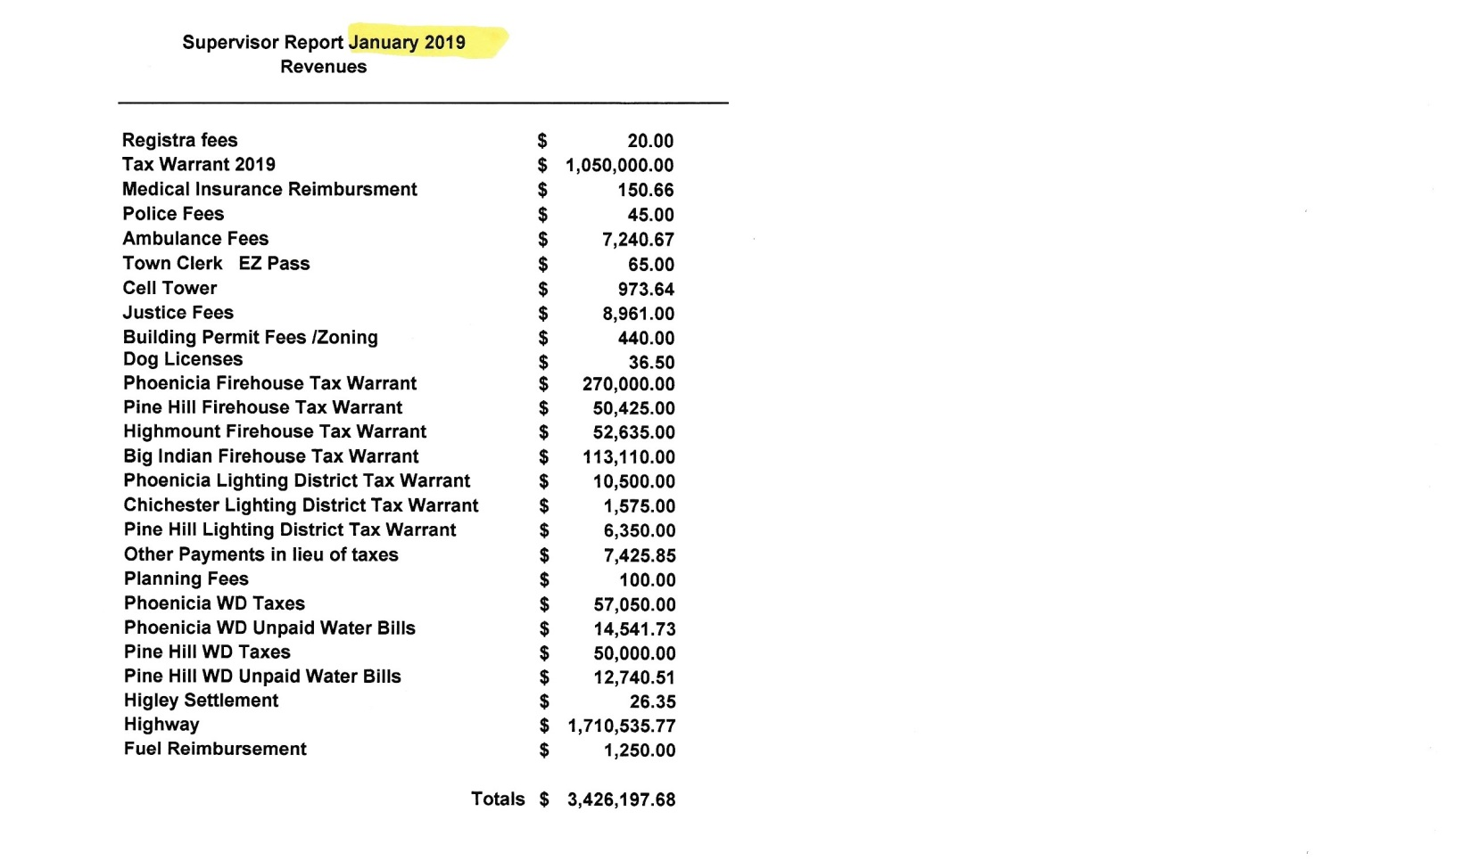

Upcoming Events
The Mobile Vet Van will be here at Town Hall on Saturday March 9th. No appt. needed for shots at 9am. All others should call for an appt. 845-901-4637

NYS Annual Burn Ban starts on Saturday March 16, no brush burning until May 14th. On may 15th, you can get a free burning permit at the Town Clerk’s office.

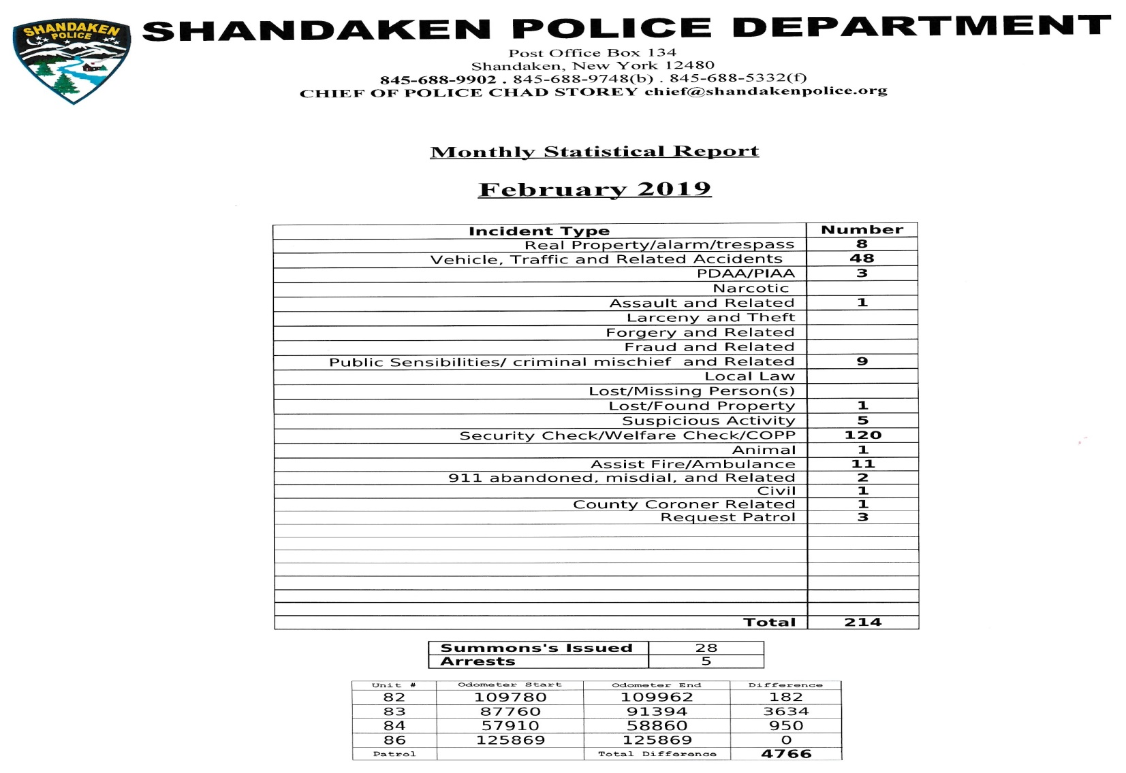
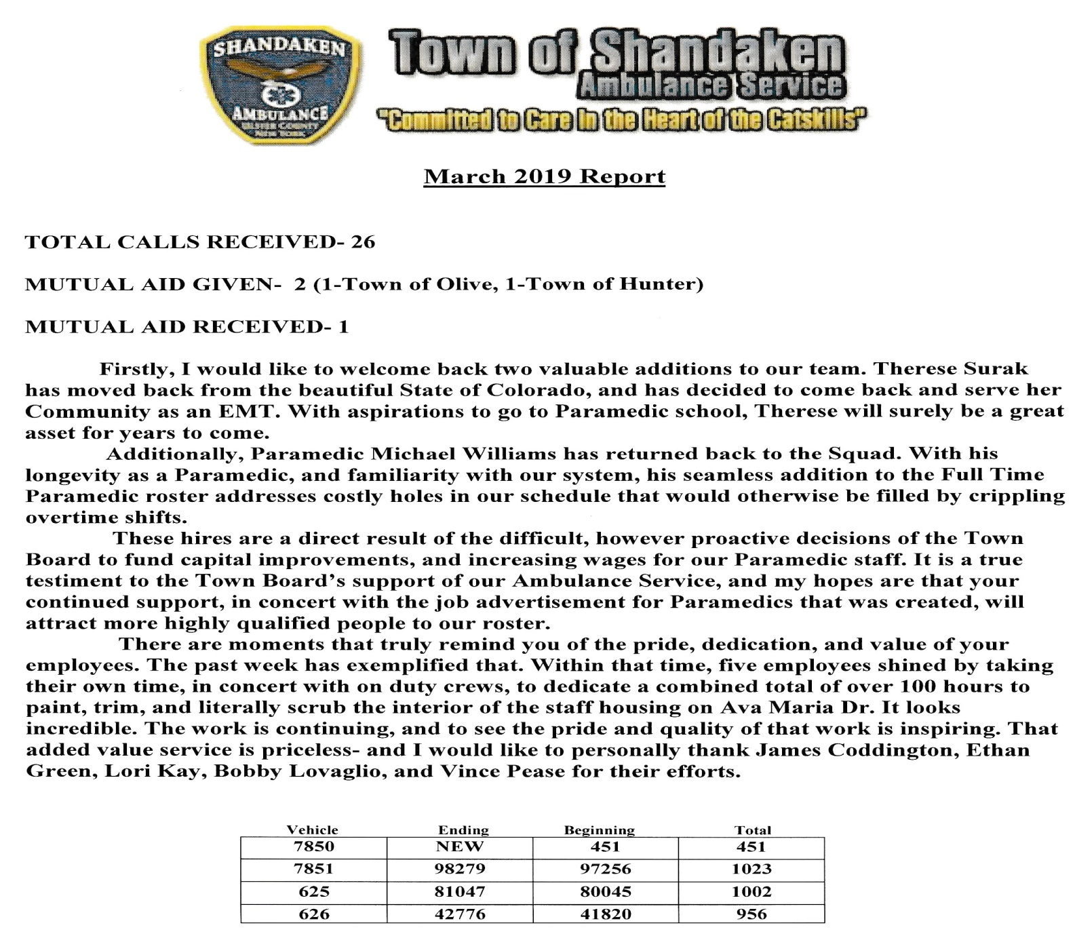

RESOLUTION #60-19 OFFERED BY: DISCLAFANI

RESOLUTION TO PAY ALL BILLS

WHEREAS, The Department of Audit and Control require Town Boards to sign and inspect all vouchers coming into the town for payment, to number and total amounts from each fund.

THEREFORE BE IT RESOLVED, that the Town Board authorize the following vouchers paid:

JANUARY 2019

General $ 361,136.78
Highway 149,382.67
Phoenicia Water 12,624.12
Pine Hill Water 1,405.63
Phoenicia Lights 1,149.93
Chichester Lights 165.38
Pine Hill Lights 657.10
------------------
$ 526,521.61

FEBRUARY 2019
General $ 325,171.53
Highway 42,417.85
Phoenicia Water 13,016.54
Pine Hill Water 2,492.36
Phoenicia Lights 1,203.65
Chichester Lights 169.91
Pine Hill Lights 681.11
------------------
$ 385,152.95

AND MOVES ITS ADOPTION

Seconded by: ALBA
ROLL CALL
AYES NAYS
BOARD MEMBER ALBA __X___ _____

BOARD MEMBER DISCLAFANI __X___ _____

BOARD MEMBER STORMS __X___ _____

BOARD MEMBER VANBLARCUM__X___ _____

SUPERVISOR STANLEY __X___ _____

Resolution # 61 - 19 Offered By VANBLARCUM
Authorize Supervisor to Enter into Lease Agreement
with Medical Associates of the Hudson Valley
Whereas, the Town of Shandaken, owns a building located at 9 Ava Maria Drive, Phoenicia, NY 12464; and
Whereas, the Town Board wishes to continue the use of the building as a Medical Arts Facility for the availability and convenience of Town residents; and
Whereas, Medical Associates of the Hudson Valley has shown interest and is prepared to enter into a lease agreement for a period of five (5) years.
Therefore Be It Resolved the Town of Shandaken Town Board hereby authorizes the Town Supervisor to enter into said lease agreement for the benefit of the Town and its residents and to perform such duties as outlined in lease agreement.
And Move Its Adoption
Seconded by: STORMS
ROLL CALL
AYES NAYS
BOARD MEMBER ALBA __X___ _____

BOARD MEMBER DISCLAFANI __X___ _____

BOARD MEMBER STORMS __X___ _____

BOARD MEMBER VANBLARCUM__X___ _____

SUPERVISOR STANLEY __X___ _____

Resolution # 62 - 19 Offered By STANLEY

Resolution to Rename Town Owned Road Old Route 28 to Veteran’s Way

Whereas, a method has been developed to implement the Enhanced 9-1-1 Street Addressing; and
Whereas, There are duplicate street names within the Town of Shandaken which do not meet national E911 addressing standards; and
Whereas, the Town of Shandaken had sent letters to all adjacent property owners on the proposed street name changes in December of 2018 and there was no public comment, nor opposition to the proposed changes.
Therefore Be It Resolved the Town Board of the Town of Shandaken hereby renames the following street as follows:
Old Route 28, Phoenicia, emanating from a point intersecting NYS Route 28 near 1114 Old Route 28 (SBL # 13.12-1-21) and terminating at a point east intersecting NYS Route 28 near 1003 Old Route 28 (SBL # 13.16-2-41) to be changed to Veteran’s Way.
And Move Its Adoption

Seconded by: VANBLARCUM
ROLL CALL
AYES NAYS
BOARD MEMBER ALBA __X___ _____

BOARD MEMBER DISCLAFANI __X___ _____

BOARD MEMBER STORMS __X___ _____

BOARD MEMBER VANBLARCUM__X___ _____

SUPERVISOR STANLEY __X___ _____

RESOLUTION #63-19 OFFERED BY: STORMS

AMBULANCE TECHNICIANS
WHEREAS, under §20 of the Town Law, the Town Board shall designate all appointed officers and employees of the Town;
THEREFORE BE IT RESOLVED that the following personnel be appointed to the Shandaken Town Ambulance at the following rates:
M. Williams – FT Medic @ $19.30/hr & T. Surak – PT EMT @ $12.10/hr

AND MOVES ITS ADOPTION

Seconded by: STANLEY
ROLL CALL
AYES NAYS
BOARD MEMBER ALBA __X___ _____

BOARD MEMBER DISCLAFANI __X___ _____

BOARD MEMBER STORMS __X___ _____

BOARD MEMBER VANBLARCUM__X___ _____

SUPERVISOR STANLEY __X___ _____

RESOLUTION #64-19 OFFERED BY ALBA

RESOLUTION APPROVING GRAVEL CRUSHING BID

WHEREAS, the Town of Shandaken Highway Department advertised for bids for crushing of item 4 at the Town owned gravel bank following the Town Board meeting on February 6, 2017; and

WHEREAS, bids were received at the Town Clerk’s Office, Shandaken Town Hall, 7209 Route 28, PO Box 67, Shandaken, NY 12480 no later than 3pm on Monday, March 4th, 2019 with bids to be opened at the Town Board meeting on the same date at 7pm;

CLARK – PO BOX 427 DELHI, NY 13753 $4.35 ton
NY CRUSHING PO BOX 1294 KINGSTON NY 12402 ¾” minus $7.45 ton, 1” minus $7.10 ton

THEREFORE BE IT RESOLVED, that the Town of Shandaken Town Board approve the bid from \
CLARK COMPANIES, PO BOX 427 DELHI, NY 13753

and will furnish a closed circuit plant, fuel and manpower to run the plant and loader.
AND MOVES ITS ADOPTION

Seconded by: DISCLAFANI
ROLL CALL
AYES NAYS
BOARD MEMBER ALBA __X___ _____

BOARD MEMBER DISCLAFANI __X___ _____

BOARD MEMBER STORMS __X___ _____

BOARD MEMBER VANBLARCUM __X___ _____

SUPERVISOR STANLEY __X___ _____

RESOLUTION #65-19 OFFERED BY DISCLAFANI

Resolution Setting Public Hearings and Special Meeting

Whereas, the Town of Shandaken, would like to set a Public Hearing on applying for CDBG Grants.

Therefore Be It Resolved, that the Town of Shandaken Town Board does hereby call for a Public Hearing to apply for CDBG Grants - Monday, April 1, 2019 @ 6:45pm at the Shandaken Town Hall, 7209 Route 28, Shandaken, NY to hear all those in favor and against such actions.

AND MOVES ITS ADOPTION

Seconded by: STORMS
ROLL CALL
AYES NAYS
BOARD MEMBER ALBA __X___ _____

BOARD MEMBER DISCLAFANI __X___ _____

BOARD MEMBER STORMS __X___ _____

BOARD MEMBER VANBLARCUM__X___ _____

SUPERVISOR STANLEY __X___ _____

RESOLUTION #66-19 OFFERED BY VANBLARCUM
MARRIAGE OFFICER – ALAN FLIEGEL
WHEREAS, Pursuant to New York State Domestic Relations Law, the Governing Body of a municipality has the right to appoint Marriage Officer who shall have the authority to solemnize a marriage within the territorial jurisdiction of such municipality, and which marriage shall be valid if performed in accordance with other provisions of law, and
WHEREAS, According to said Law, the Marriage Officer appointment is valid for a period of four (4) years, and Officer shall receive no salary or wage, and is authorized to accept and keep up to seventy-five ($75.00) dollars for each marriage that he or she officiates, to be paid by or on behalf of the persons married.
WHEREAS, ALAN FLIEGEL, a resident of the Town of Shandaken, has requested the Town Board to appoint him to the position of Marriage Officer for the period of four (4) years or until such time as his appointment is withdrawn pursuant to Domestic Relations Law 11-c, whichever comes first.
NOW, THEREFORE BE IT RESOLVED, that Alan Fliegel be appointed Town of Shandaken Marriage Officer – This resolution shall take effect immediately. Appointment Expires April 1, 2023.
AND MOVES ITS ADOPTION

Seconded by: STANLEY
ROLL CALL
AYES NAYS
BOARD MEMBER ALBA __X___ _____

BOARD MEMBER DISCLAFANI __X___ _____

BOARD MEMBER STORMS __X___ _____

BOARD MEMBER VANBLARCUM__X___ _____

SUPERVISOR STANLEY __X___ _____

The meeting adjourned at 8:46 on a Disclafani/Vanblarcum Motion.

Signed this 5th day of March, 2019

________________________________
Joyce Grant – Town Clerk

